Annexure 8 to our reply to your Show cause notice dated 16th June 2015.

Reply to your Result of Enquiry Report in Tamil

We have extracted below translated version of your paragraphs, in italics, from your enquiry report warranting a response and our response is given below the respective extract.

1. Society under the control of foreign entity

When we inspected the society sub rules we found that society is not independent, that it has been formed to function under the control of Netherland based Stichting Greenpeace Council to fulfil Stichting's objectives.
According to Society Sub rule Art 8, the governing body(board?) the person selected as society head by the governing body should have the approval of Stichting.

The ED is someone who is authorised by Stichting Committee.

The fact that the administration of the society is handed over to the above person and all the cases filed on or by the society in the name of this person establishes that the society is acting under the control of the foreign entity.

Response:
It is incorrect to state that GPIS is not functioning independently but is under the control of Stitching Greenpeace council (SGC) on the basis of isolated reading and interpretation of clauses in the MoA.

- As per the scheme of the Tamil Nadu Societies Registration Act (Act) followed in our MoA, our society is managed by the Executive committee (EC) which in turn is elected by the General body of members. SGC does not have any power to approve or appoint the members of the EC or the General body. Therefore the presumption that the President, who is just one of the members of the EC, enjoying inter alia the confidence of SGC would result in our society functioning under the control of SGC is incorrect. Our General Body consists of 25 members interested in Environment and is too large a body to be led by any external body. Similarly the EC consists of 7 persons of eminence who are individuals in their own right and who have independent minds of their own.

- The President himself is elected from and amongst the members of EC only as per Article 8. An “approval” in case of the President or “cooperation” used in the context of ED is not to be equated with imposition. The SGC has no power of veto in the election of the President or appointment of the ED.

- Considering the fact that Greenpeace is an International organisation with activities/presence across the globe and a brand name, SGC has to suitably protect its image.

- Society being a legal person can only act through its office bearers and that does not establish that the society is acting under the control of a foreign entity. In fact there is no evidence produced by you in support of your allegation that our society is “acting under the control of the foreign entity”. Surmises and assumptions based on isolated reading without a harmonious interpretation of the circumstances cannot be the basis for the serious charge made in the SCN and enquiry report

2. Objectives of the Society

The inspection was carried out to assess whether the objectives of the society are in compliance with the Tamil Nadu Society Registration Act, 1975 section 3, and Tamil Nadu Society Registration Rules, 1978 rule 3.
- to promote protection and preservation of the environment
- to promote peace and nuclear disarmament
The actions that will be taken to achieve the objectives

The objectives and the actions of the mention in the bylaws are in compliance with the society registration act and the rules.

As this is just an observation, no response is called from our end.

3. Society Funds

(1)All the society funds are received from foreign countries. Below are the agencies which are donating:

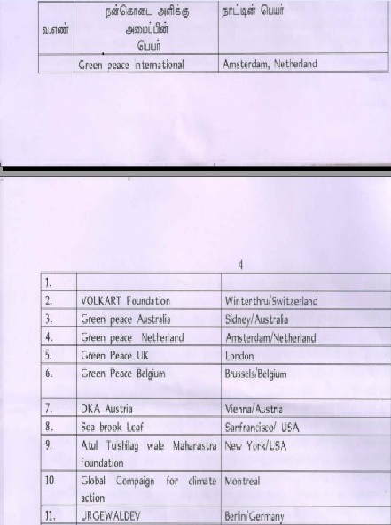

According to the above Greenpeace International and Greenpeace Netherlands are funding crores of rupees on an annual basis under the heading of environmental programmes.

(2) GPIS submitted a copy of the reports submitted to MHA as Form FC on the information pertaining to the funds received from the above mentioned foreign entities. Foreign contributions received were filed with the Secretary, foreigners division which operates under the MHA in the following forms- between 2004-5 and 2010-11 Form FC 3 and from 2011-12 to 2013-14, Form FC 6

It is stated that all these donations are credited to the IDBI bank account (no )in Thousand Lights Branch, Chennai.

(3) Following are the funds received from foreign entities between 2004-5 and 2013-14 on an annual basis

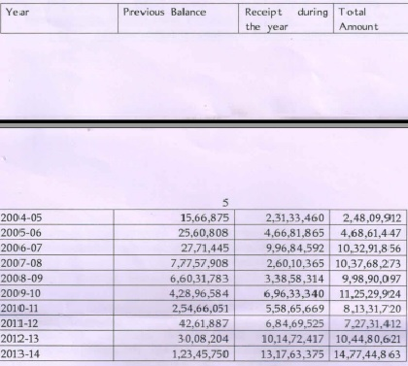

(4) Comparisons of the form FC 3/FC 6 data submitted to the Government of India with the income/expenditure statements data filed with this office on the foreign contributions is captured in the table below

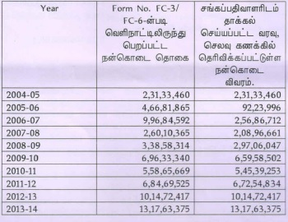

Column 1 heading - donations received from foreign countries as per for form fc 3/fc 6
column 2 heading - details of foreign donations mentioned in the income expenditure statement registered with the society registrar

According to the above between 2005-6 and 2011-12 there are differences between the amounts received from the foreign agencies with the amounts mentioned in the annual reports. Notably, in the year 2005-6, 4.66 crores has been received as foreign donations but the annual report shows the foreign donations are Rs. 9.23 lakhs only. Similarly, for the year 2006-7, 9.97 crores have been received but the annual report shows 2.57 crores. Similarly also in the years 2007-8, 2008-9, 2009-10 and 2010-11, the details of foreign contributions in the income-expenditure report were reduced and shown.

Only after enquiring with the society, the truth behind the differences between the foreign donations received and the amount mentioned in the annual reports can be understood.

Response:

Please see paragraph II (B) of our response to your SCN

4. Bank accounts
In the form FC3/FC6 submitted to the Government of India, that all the foreign donations are credited to the IDBI bank account no().

Apart from this, during the inspection we came to know that the society also has the following bank accounts:

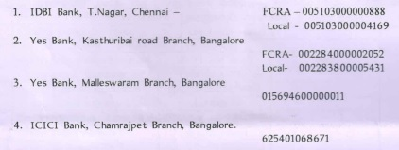
All the expenditures transactions of the society are made online. Copies of all the online transactions were inspected. Also when inspecting the expenditure vouchers it was understood that money has been spent under the environmental pollution free activities.

While inspecting the statements for 2013-14, the expenses were made for the following headings as below:

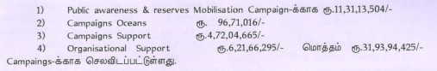
Response:

No comments needed on details of bank accounts. However the figures of expenditure for the FY 2013-14 are incorrect and incomplete. The correct figures are given below

Particulars | As per your Report | Correct Figure as per our Audited Accounts
Public awareness and Resource mobilisation Campaign | 11,31,13,504 | 11,33,13,504
Campaigns | 96,71,016 | 9,67,10,161
Campaigns Support | 4,72,04,665 | 4,72,04,465
Organisational Support | 6,21,66,295 | 6,21,66,295
Total | 23,21,55,481 | 31,93,94,425

Due to the transposition and transcription errors in the enquiry report, the actual total comes to only Rs. 23, 21, 55,481 although the correct total of Rs. 31, 93, 94,425 has been shown in your report.

5. Society’s operations location

Initially the society was functioning from Besant Nagar 3rd Avenue and later from No 47, 2nd Cross, Ellaiamman Colony, Gopalpuram .

The society activities are being conducted at the above address through its employees. However none of the administrators of the society are responsible for this office.

Since the society started functioning all the AGMs and Governing Body meetings have been happening only in Bangalore instead of Chennai. The details below show wherein Bangalore the AGMs have been taking place.

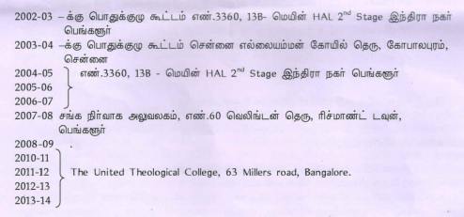

As mentioned above, only the AGM 2003-4 had happened in Chennai. AGMs for all the other years had happened only in Bangalore. The registered office has been maintained for namesake and all the society activities are happening from Bangalore.

Response:

Please refer Sec 26 of the Act. This section does not specify the venue of the AGM and it is not mandatory to hold the AGM in the city where the registered office is situated. Greenpeace India Society is an all India organisation with its registered office at this address in Chennai. Its Executive Committee members and ordinary members are living in different cities. It has office in different cities and its managerial and other staff functions from the different offices of the Society just like any other company. It has been conducting its AGMs from Chennai and Bangalore as convenient to the members and there is nothing wrong in this.

Further your inspection was carried out in our registered office at Chennai. The extent of operations that an organisation should have in its registered office or in a location is a matter to be decided by the organisation

6. Memorandum and Byelaws of the society

The details that required to be mentioned in the memorandum are given in Society’s Registration Act Section 6. The details that need to be mentioned in the byelaws of the society are explained in the Society’s Registration Act Section 8 and the Society Registration Rules, Rule 6.

The memorandum of the society is in compliance as per the above stated laws and rules, but the society byelaws that need to be in compliance under society registration rules, rule 6 have some details missing.

The details are below:
- Society Registration Rules, Rule 6 (1)
- The society office address is not mentioned according to class-b.
- The society start date is not mentioned according to class-c
- It is not mentioned under within which registered district jurisdiction society is located as per class-d
- The office hours of the society are not mentioned as per class-e
- As per the objectives mentioned in the memorandum and the actions that will be taken to meet the objectives is not mentioned in the byelaws as per class- and class-g
- There is no mention about submitting annual reports and other reports to the registrar of societies in the byelaws as per class-o
- Providing copies byelaw copies, income-expenditure statement copies for members and the amount payable towards that is not mentioned as per class –q

Response:

As per Rule 7 of the Tamil Nadu Societies Registration Rules the MoA and the Bye laws are submitted to the Registrar at the time of Registration and every subsequent change is intimated. Under Section 10 of the TN Societies Registration Act, certificate of Registration issued by the Registrar shall be the conclusive evidence that the society therein is duly registered. There has been no observation in this regard from you so far. However we are willing to make suitable amendments after obtaining prior permission of the Income tax Dept. and the approval of the General body. You would appreciate that some clauses like objects, address, activities etc. find place in MoA in any case. Further date of formation cannot be put in the bye laws as bye laws are submitted as a pre requisite for and before the registration of the society itself.

7. Details that contradict the society registration rules
Details of byelaws that are against the society registration act and the rules
1. Byelaw Article 2(3) states the amount to be collected as subscription will be decided by the governing body.
Joining fee for new members and the subscription fee are not determined by the governing body, they need to be mentioned in the byelaws itself. If the amounts need to be changed, then it should be changed with the approval of the general body and brought in as an amendment to the byelaw, i.e. byelaw Article 2(3) are not suitable with society registration rules 6(1) class-j(2)
2. Society byelaw Article 8 mentions that “there shall be a president, i.e. the person who is chosen as the president of the society has to be accepted by the agency called “Stitchting Greenpeace Society” operating in a foreign country. According to the society registration act 1975 section 15(3) governing bogy members are chosen from the general body and within the governing body, there are provisions to choose society employees like the president.
Saying that the person chosen by the governing body should be recognized by the agency called “STICHTING Greenpeace council” in the byelaw is destroying the purpose section 15(3). It seems like that there is an indirect order given to the society to appoint only a person recognized by the “STICHTING Greenpeace council” can be appointed as the head of the general body and then in the governing body also.

Response

8. Annual report submission
This society was started in July 2002. Annual general meeting has been called every year and reports were submitted. The reports for the years 2002-03 and 2003-04 were filled and accepted on record. Even though the reports between 2004-05 and 2013-14 were filled they have not been accepted on record and kept pending. Dates of AGM and reports filled are below.

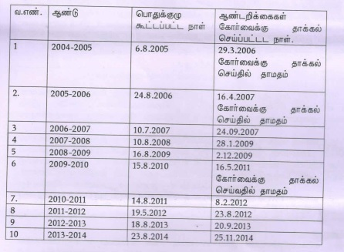
Table SNO,
year Date of AGM , date of submission of annual reports
2004 - 2005 29.3.2006, delay in submitting the annual report
2005- 2006 16.6.2007 delay in submission of annual reports
2009 - 2010 16.5.2011 delay in submitting annual reports
According to the Tamil Nadu society registration rule 22. AGM should be called within six months of the end of financial year. Reports should be submitted within 6 months of the AGM. Financial year of the society is between April and March. i.e AGM should be called before the month of September every year. According to that between the years 2004 – 2005 and 2013 – 2014 AGMs were called within the time but in the years 2004-05 , 2005-06 and 2009-10 submission of the reports have been delayed.

10. Changes in governing body
According to Tamil Nadu society registration act section 15(4) the tenure of the members in the governing body should not exceed three years. Section 15(2) and society registration rules 17(2) Form VII should be submitted to records within three months from the date of changes in the governing body. Society byelaw Article 5(2) mentions that the tenure of the first governing body was one year and the tenure following governing bodies will be two years. According to that, the governing bodies were chosen during the following AGMs

Table
General body year | General body election

Form VII has been submitted only for the changes on 15.8.2010 and 19.8.2012. Form VII for the rest of the changes is not submitted. i.e. non submission of the Form VII violates society registration act section 15(2)

11. When the society was started the following members were members of the society and members of the governing body
T Mohan | Head | Lawyer | Chennai
Achin | member | Journalist | Delhi
Lalita Ramados | member | Educationalist | Alibag
Bittu | member | journalist | mumbai

Post this there were addition and resignation of members. Form VII for the following members were not filled

Raman
Narasima rao
Pattabiraman

Non submission of the Form VII for appointing new members, violates Tamilnadu society registration act section 15(2) and registration rule 17(2)
Conclusions based on the above
1. Greenpeace India Society, instead of functioning independently is functioning as a sister agency under the control of the stitching Greenpeace Council
2. There are differences in amounts between the FC3/FC6 submitted to MHA on foreign contributions and the income expenditure statement submitted to the society registrar
3. Even though the society registered office is in Chennai, all the society meetings happened in Bangalore. Society administration is functioning from Bangalore. The registered office in Chennai is for name sake, it does not have any administrators but run by employees
4. Details mentioned in Society registration rule 6(1) Column b,c,d,e,f,g,h,o and q are not included in byelaws of the society
5. STICHTING council deciding the president and the Executive director is against the principle that the society should function with democratically elected members
6. The documents submitted with the annual reports indicate that resigned members were shown as existing members and they were shown as participating in the AGMs. Submitting non attested copies of the AGM attendance shows that the AGMs were not conducted properly i.e the annual documents are not acceptable

9. Short falls of the annual report
While inspecting the reports pending without being accepted for short falls, the following short falls were identified.
(1) The photo copy of the typed itinerary of the AGM itinerary In the year2005-06 does not have the signature of the society president. Also instead of the arrested copies of the AGM attendance a Xerox copy is submitted with other documents. i.e the annual report is not acceptable.
(2) (i) The attendance of the AGM for 2006-2007 were just Xerox copies without any attestation.
(ii) The person who has signed as the president in the year is MRS Shobita Punja but it is not clear when she was chosen by the governing body since Form VII is not submitted. the 2008 – 2009 annual reports also has the same problem i.e both 2006-2007 and 2008-2009 annual reports are not acceptable
(3) The attendance of the participants of the 2007-2008 AGM was not submitted with the annual report. Hence this is also not accepted
(4) The person named Lalita Ramdas resigned from being a member of the society on 15.1.2007 but her name is mentioned as member in Form VI in the annual reports between 2007-2008 and 2013-2014. She has also been part of all the AGM and has signed on the register. Showing a member who resigned as an active member continuously is a wrong thing. i.e. the reports between 2007-2008 and 2013-2014 cannot be accepted.

