Photo of 2013

As I looked over the amazing photography produced by and for Greenpeace around the world in 2013, I come back to this image by Denis Sinyakov as the Greenpeace USA Photo of the Year for 2013.

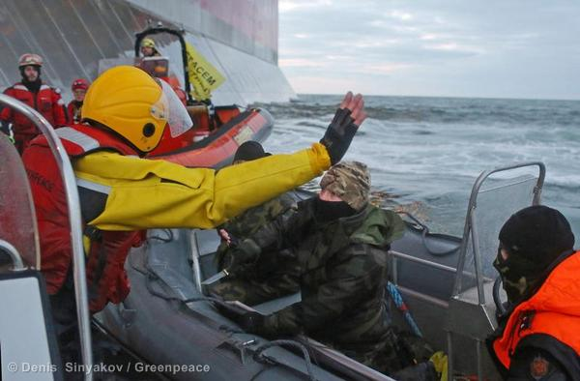

This image captures the dramatic moment that the gloves came off in the fight to save the Arctic. This is the moment teeth were bared and shots were fired; the moment when the extent to which the multinational oil companies will go to protect their interests was revealed.

Companies drilling for oil in the Arctic are ready and willing, without hesitation, to risk lives, limbs and the very viability of life on earth. They have no regard for consequences. The inevitable oil spill in this previously unspoiled wilderness is not worth even bringing equipment to deal with it along with them. Free speech and freedom have no place in the dominion of oil which is wherever they decide to drill.

For taking this photo and getting it out to the world, freelance photographer Denis Sinyakov and videographer Kieron Bryan were taken into detention a day later with the 28-member crew of the Greenpeace ship Arctic Sunrise by armed FSB agents who boarded by repelling down from a helicopter. The ship and the Arctic 30 were seized on Sept. 19 and kept in prison in Murmansk before being transferred to St. Petersburg where Sinyakov was released on Nov. 21. They are all still are charged with hooliganism and piracy which carry long prison sentences.

Appearing in court on Sept. 26, Sinyakov said: “This ‘criminal activity’ is journalism and I will continue to practice it… I am a journalist… My only weapon is my camera.” Denis Sinyakov is a master of that instrument. He documented protests at oil platforms in the Russian Arctic in 2012. He documented the thousands of hectares of forests and mires in Siberia turned into environmental disaster zones by oil spills in just in a matter of years.

Through his web site, and in the image banks of global news agencies, a tremendous body of work created by Denis can be viewed. There is the beauty of nature and native peoples of the Russian arctic. He captures the pain and horror of war on several continents. Sitting for two months in a prison must be hard for such a person used to being out in the middle of things. His last posting is a carefully executed drawing of the view from his last prison cell. I hope it is the last prison cell he ever sees the inside of.

So where will this willingness to use extreme force against peaceful protest take us. As the Arctic 30, presently prevented from traveling outside St. Petersburg, contemplate their future, so should all reasonable people contemplate how exploiting Arctic oil resources will impact the entire planet.

In the smoke-shrouded darkness there is a glimmer of hope. Renewable energy resources are being installed and adapted all around the world. Fewer people in urban areas are driving and more are enjoying car-free lifestyles. Other technologies are reducing the demand for fossil fuels. The key to unlocking ourselves from this destructive cycle is widespread understanding that it is far safer and less expensive to leave the remaining oil, gas, coal, tar sands and other industrial pollutants where they are than to bring them to market. This is a mortal threat to very powerful and entrenched interests that we can see, thanks to Denis Sinyakov, will stop at nothing to protect themselves.

