24 new coal-fired power projects approved in China in first half of 2021: Greenpeace

Key points:

- In the first half of 2021, local development and reform commissions (DRCs) approved the construction of 24 coal-fired power plants, a total 5.2 gigawatts (GW) of coal-fired power capacity. This is a year-on decrease of 78.8%.

- Three of these 24 projects are large-scale non-CHP coal-fired power plants in Anhui and Shaanxi, which were included by the provincial governments in key project lists. Key projects¹ are proposed by provincial governments to receive national funding, policy support, and priority status if approved by the central government as having strategic benefits.

At present, 104.8 GW of coal capacity that has yet to go online remain on these key project lists.The provincial key project lists include a total of 104.8 GW of coal-fired power capacity in pipeline. The provinces with the most projects in the pipeline are Shaanxi, Guangdong, Gansu, and Guizhou. Meanwhile, Shandong and Zhejiang’s pipeline now contains no coal-fired power projects, and should be followed as a new frontline in China’s energy transition.

- Three of the 24 projects were non-combined heat and power (non-CHP) coal-fired power plants, accounting for 3.3 GW or 64.0% of the total H1 2021 approved capacity, were officially tied to power demand or national energy strategy for cross-regional transmission. These three projects were located in Anhui and Shaanxi.
  - These projects were approved because of “taking advantage of resources within the province to develop local economies and meet local power demand.”
  - One project, the Datang Shaanxi Xiwangzhai Coal and Electricity Integrated power project, was approved as part of the national “West-to-East Power Transmission” national energy strategy.

- 21 of the 24 projects that did gain approval, together accounting for 1.9 GW in total capacity, were smaller back-pressure cogeneration units that mainly provide heating.

-------------------------------------------------------------------------------------------------------------------------------

5.2 GW approved in H1 2021, a year-on decrease of 78.8%

The majority of China’s carbon emissions come from combustion for generating energy, which accounts for around 88% of the total emissions, with 41% coming from coal consumption alone.

A review of data collated from public disclosures by related provincial government departments showed that local DRCs approved 5.2 GW of capacity in new coal-fired power plants, which is a 78.8% decrease compared to the 24.3 GW approved in the first half of 2020.

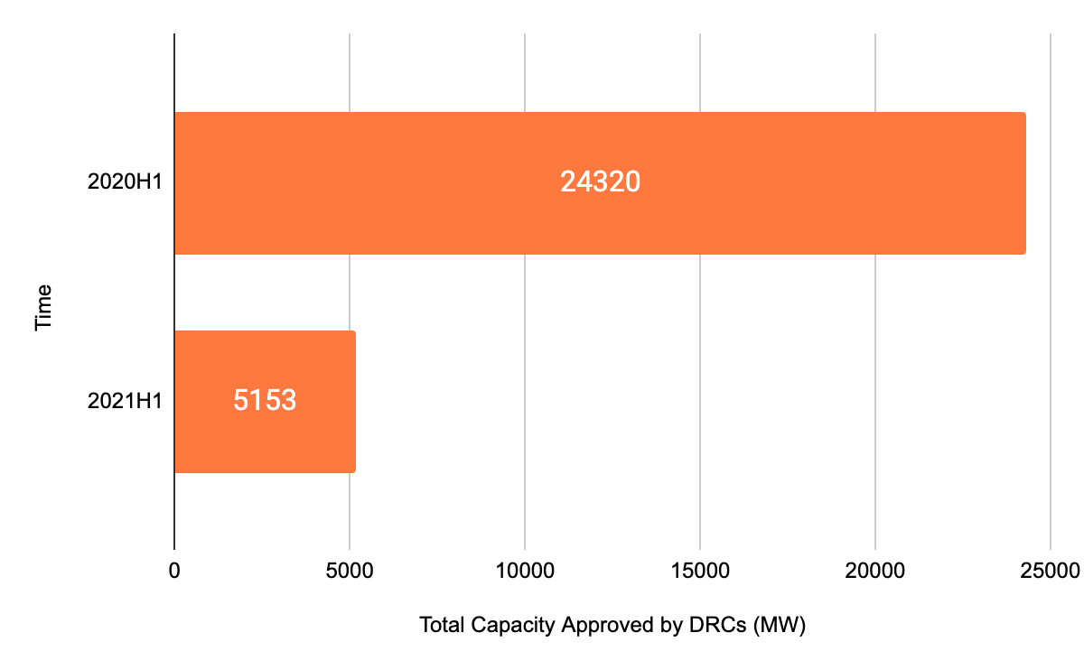
Graph 1. A comparison of total coal-fired power capacity approved by DRCs in 2020 and 2021.

Project type

Of the 5.2 GW of new coal-fired power capacity approved during the first half of 2021, three large-scale coal-fired power plants in Anhui and Shaanxi account for 64.0% with a combined capacity of 3.3 GW.

The other 36.0% of capacity comes from 21 smaller projects with a combined capacity of 1.9 GW. These projects were distributed over nine different provinces, with the most capacity approved in Hubei (350 megawatts (MW)), Chongqing (350 MW), and Fujian (320 MW). Hubei and Chongqing both approved the construction of 350 MW supercritical cogeneration units for the Chongqing Nanchuan Industrial Park Shuihong Group Cogeneration Project and the Hubei Province Jingneng Shiyan Cogeneration Two-Phase Project’s third unit, respectively. The other 19 projects are back-pressure systems to provide heating, and are mostly used in industrial parks or residential areas.
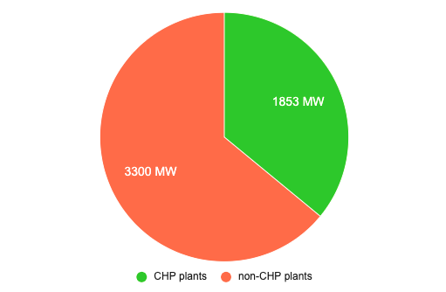
Graph 2. The percentage of China Mainland’s new-approved coal-fired power capacity by project type.

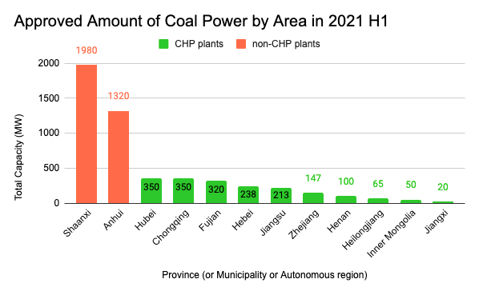
Graph 3. New approved coal power capacity by province, municipality, or autonomous area.

Details on project approval process

New-approved coal capacity concentrated in traditionally coal-dependent regions, and all projects were large-scale (more than 0.6 gigawatts per unit).

The Datang Shaanxi Xiwangzhai Coal and Electricity Integrated power project was approved as part of the national “West-to-East Power Transmission” national energy strategy. This project includes two 660 MW new power plants and is one half of an integrated coal power project coupled by a ±800kV Ultra-high voltage direct current (UHV DC) power line for cross-regional power transmission from northern Shaanxi to Hubei.

Project approval justifications for the 3 larger coal power projects included: “promote the company’s industrial optimization”, “strengthening the company’s market competitiveness”, and “continuing the consolidation of the coal market”, “strategic consolidation of conglomerate’s coal power generation base”, “taking advantage of local natural resources”, “strengthening the construction of energy and chemical industrial bases”, and “promoting the integration of coal fired power projects”.

Project finance for two of the three non-cogeneration projects came from state-owned enterprises. This could come from several reasons, including state-owned and private companies backing off of financing new coal power generation after the latest signals from the central government, and because of recent difficulties in securing finance for these types of projects.

Over the first half of 2021, the timing for new approvals for projects with coal capacity came in February and March, accounting for 38.7% and 28.1% of the total, respectively. On April 22, 2021, at the Leaders’ Summit on Climate, Chairman Xi Jinping said, “China will strictly control coal-fired power generation projects, and strictly limit the increase in coal consumption over the 14th five-year plan period and phase it down in the 15th five-year plan period.” Since then, 14 projects with coal-fired power capacity have been approved, notably small scale cogeneration projects (<100MW).
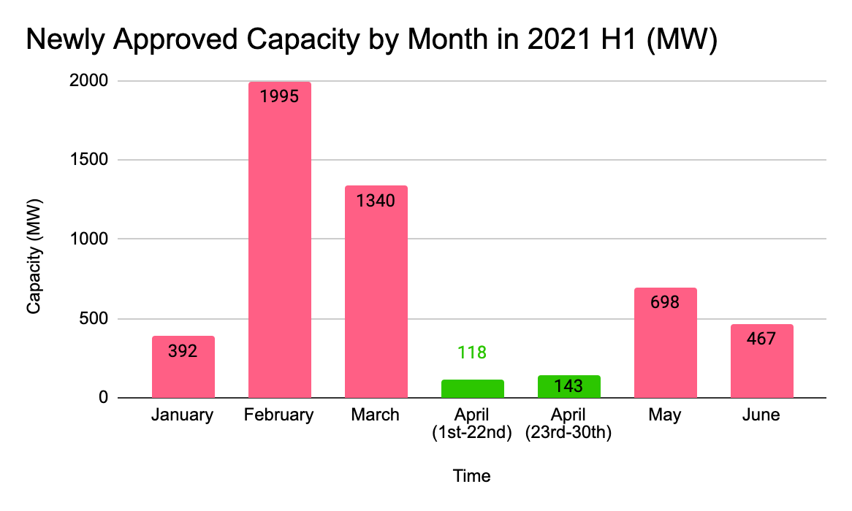
Graph 4. New approved coal power capacity by month.

There are 104.8 GW of coal capacity in provincial key projects lists

A review of 27 publicly available province level key projects lists (重大项目), which receive financial support, preferential policy work, and priority status from the national government which recognizes the projects as having strategic value, showed that these lists contain 79 coal power projects, amounting to more than 104.8 GW of coal-fired power capacity.

In total, 23 different provinces have coal power projects on their key projects lists this year. This is a 20.9% increase from total coal power capacity on publicly available province level key projects lists from 2020, though only 21 provincial governments made these lists public in 2020, compared to 27 this year.

The provinces with the greatest capacity of coal power on their key projects lists were Shaanxi (14.0 GW), Guangdong (13.6 GW), and Gansu (10.1 GW).
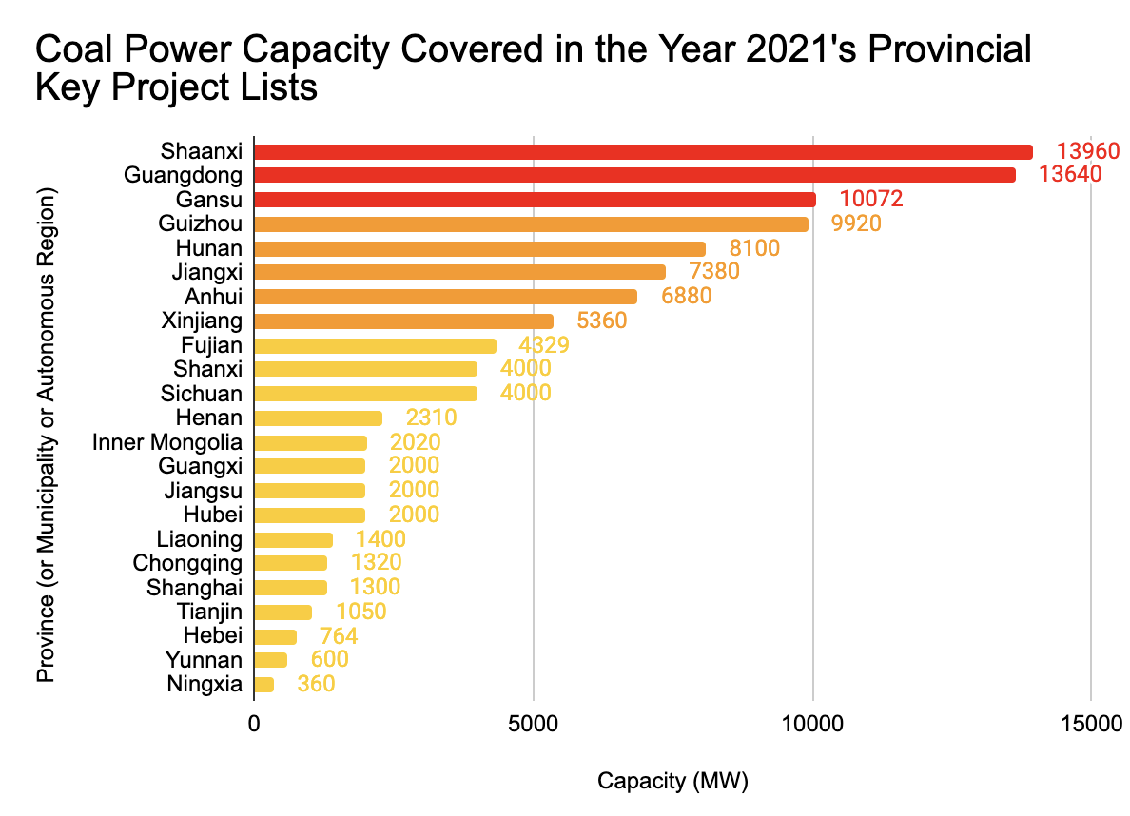
Graph 5. Coal power capacity on provincial key projects lists in 2021.

Electricity supply has featured as a top-ranked concern for provincial governments as heat waves drove up electricity demand, with local governments regulating electricity supply and staggering industrial projection to lower peak load. In July, Xi’an, the capital of Shaanxi province experienced widespread electricity shortages, as electricity demand surged during a heat wave that lasted from June 28 to July 14 and broke previous peak usage records six different times. In the 14th five-year plan period, securing long-term electricity supply ranked first among justifications for constructing new power generation capacity.

In Shaanxi’s provincial 14th five-year plan, which ends in 2025, total electricity production capacity is planned to exceed 136 GW, of which only 65 GW is planned to come from renewable energy.

Province, municipality, autonomous region | Total Capacity in 2021 List (MW) | Total Capacity in 2020 List (MW) | Year-on difference (MW)
Shanxi | 4000 | 10040 | -6040
Shaanxi | 13960 | 18670 | -4710
Xinjiang | 5360 | 7507 | -2147
Shandong | 0 | 2025 | -2025
Zhejiang | 0 | 1605 | -1605
Jiangxi | 7380 | 7978 | -598
Tianjin | 1050 | 1600 | -550
Guangdong | 13640 | 14160 | -520
Henan | 2310 | 2750 | -440
Chongqing | 1320 | 1320 | 0
Shanghai | 1300 | 1300 | 0
Hebei | 764 | 700 | 64
Liaoning | 1400 | 1200 | 200
Ningxia | 360 | 36 | 324
Yunnan | 600 | 0 | 600
Fujian | 4329 | 2879 | 1450
Hunan | 8100 | 6100 | 2000
Guangxi | 2000 | 0 | 2000
Jiangsu | 2000 | 0 | 2000
Gansu | 10072 | 4000 | 6072
Guizhou | 9920 | 2790 | 7130
Anhui | 6880 | No Statistics | -
Sichuan | 4000 | No Statistics | -
Inner Mongolia | 2020 | No Statistics | -
Hubei | 2000 | No Statistics | -
Hainan | 0 | No Statistics | -
Tibet | No Statistics | No Statistics | -
Qinghai | No Statistics | No Statistics | -
Jilin | No Statistics | No Statistics | -
Heilongjiang | No Statistics | No Statistics | -
Total | 104765 | 86660 | -
Table 1. Comparison of key project lists in 2021 and 2020 by province.
Three provinces -- Yunnan, Guangxi, and Jiangsu -- included coal power projects this year but did not in 2020.

Two provinces -- Shandong and Zhejiang -- included coal power projects in their key projects list in 2020 but not in 2021.

Policy suggestions

2021 is the first year of the 14th five-year plan, and the first half of this year has shown a more strict standard for coal-fired power project approval. At present, the majority of coal-fired power projects are coming from coal-dependent provinces, which need closer attention and follow up from the central government. Greenpeace makes the following recommendations:

- Focus on coal-dependent provinces, which are continuing to push coal power projects on a large scale -- especially Shaanxi Province -- and set up an early warning system after conducting scientific assessment of the installed coal power reserve and provincial power sufficiency;
- Provincial governments should strictly control coal-fired power plants, stop turning to the coal industry as the first option to increase power generation capacity, and look to domestic and foreign energy transition cases. Provinces should give priority to sustainable energy sectors to realize decarbonization;
- Provincial governments should look to green production capacity investment options to develop new energy power systems and invest in research on decarbonizing energy systems in their local context.

National Energy Administration. 打赢低碳转型硬仗. April 2021. http://www.nea.gov.cn/2021-04/09/c_139869435.htm
Including publicly available information from the Development and Reform Commissions of the whole country on project approvals, and information from the online approval and supervision platform for investment projects.
1 GW = 1000 MW
The Central People’s Government of the People’s Republic of China. 西电东送：资源优势转为经济优势实现东西部共赢. 2008 November. http://www.gov.cn/jrzg/2008-11/15/content_1149889.htm
中煤新集能源股份有限公司董事会. 新集能源关于控股子公司二期项目获得核准批复的公告. 2021 January. https://pdf.dfcfw.com/pdf/H2_AN202101291455658739_1.pdf?1611935095000.pdf
Bjx.Com.Cn. 660MW！神木神信电厂首台机组获得核准批复. 2021 April. https://news.bjx.com.cn/html/20210429/1150123.shtml
The Central People’s Government of the People’s Republic of China. 习近平出席领导人气候峰会并发表重要讲话. 2021年4月. http://www.gov.cn/xinwen/2021-04/22/content_5601535.htm
Excluding Tibet, Qinghai, Jilin, and Heilongjiang
Guangzhou Municipal Industry and Information Technology Bureau. 广州市工业和信息化局关于2021年广州市有序用电方案的批复. 2021 May. http://gxj.gz.gov.cn/yw/tzgg/content/post_7273230.html
Shoudian.Bjx.Com.Cn. 云南省能源局批复：进一步扩大云南电网有序用电规模. 2021 June. https://shoudian.bjx.com.cn/html/20210610/1157553.shtml
Energy Magazine. 封面文章 | 缺电预警. 2021 August. https://mp.weixin.qq.com/s/fcyoKUluZfOoccYxMf_POQ

