Russian military and false flag sabotage operations at the Zaporizhzhia Nuclear Power Plant (ZNPP): satellite imagery analysis exposes the lies of Rosatom

Greenpeace Ukraine Briefing

4 March 2026

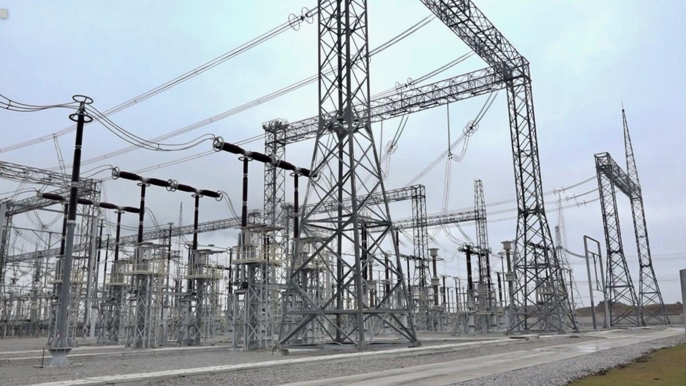
750kV transmission line at the switchyard of ZNPP, December 2020. Source: Energoatom

Greenpeace Ukraine has compiled data the from the past year on the loss of vital external electricity power lines to the Zaporizhzhia Nuclear Power Plant (ZNPP). Greenpeace has sent the analysis to member governments on Board of Governors of the International Atomic Energy Agency (IAEA) which meets in Vienna 2-4 March. During the past 12 months, the ZNPP has lost connection to one or both of these lines over a period of 296 days, including complete loss of external power on 4 occasions.

Greenpeace Ukraine analysis, including their consulting of McKenzie Intelligence Services (MIS), looked at high resolution satellite imagery of the ZNPP switchyard, the 750kV Dniprovska and 30kV Ferosplavna-1 lines as well as the Zaporizhzhia Thermal Power Plant (ZTTP) and its switchyard. The analysis provided to governments at the IAEA warns of the massive Russian disinformation campaign as all of the damage to grid lines during the period of review is a direct result of Russian deliberate attacks, including sabotage on at least six occasions. There is no evidence of any Ukraine shelling of the ZNPP electric grid network.

The key findings from reviewing the past year of loss external electricity grid connection at the ZNPP are:

- Since July 2025 there have been four occasions when the ZNPP suffered Loss Of Offsite Power (LOOP);
- Three of the LOOPs were a direct consequence of Russia’s wider military attacks on Ukraine’s electricity infrastructure, including critical sub-stations, underscoring the vital importance of stopping these attacks and the important role for the IAEA extended mission teams;
- Between February 2025-February 2026 there were 13 cases of damage to either the 750 kV Dniprovska or 330kV Ferosplavna-1 lines leading to loss of connection to the ZNPP;
- Six cases of damage have been located in territory under temporary Russian occupation in close proximity to the ZNPP or Zaporizhzhia Thermal Power Plant (ZTTP);
- Seven losses of grid connection were due to Russian shelling and missile attacks on the Ukraine electricity grid in Nikopol district, and the wider Dnipro region;
- For 296 days in the past year one or both of the grid lines to the ZNPP have been disconnected; and
- In key locations at the ZNPP and ZTTP, the IAEA mission personnel are prevented by Rosatom from accessing the site to conduct inspections.

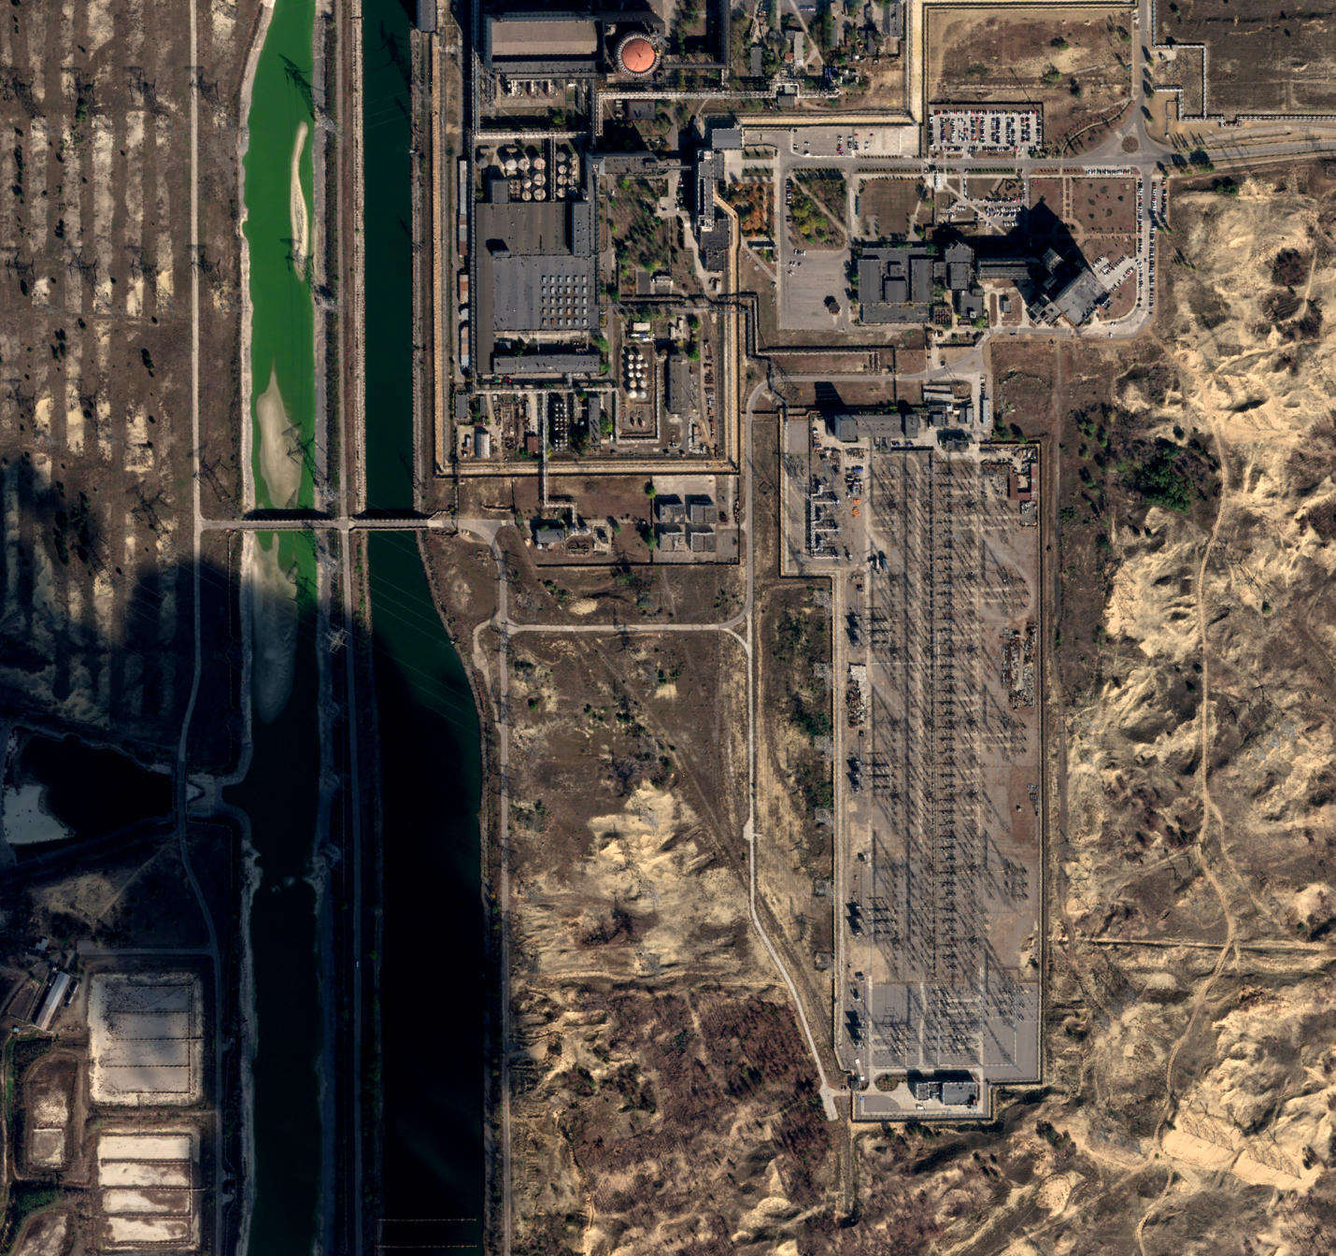
750kV transmission line at the switchyard of ZNPP Source: 15 October 2025 @Airbus

A summary of Russian military damage inflicted to the external power lines of the ZNPP, grid and switchyards
Date | Event | Location | Russian disinformation | Actual cause | IAEA access to location | Duration
11 February 2025 | 330kV Ferosplavna-1 line damage/loss of connection to ZNPP | Russian controlled territory ZNPP | Ukraine shelling | Damage to line at ZTTP -Zaporizhzhia Thermal Power Plant - unspecified Russian military activity | IAEA access denied by Rosatom | 41 days – 21 March 2025
7 May 2025 | 330kV Ferosplavna-1 line damage/ loss of connection to ZNPP | Nikopol district | Lost connection | Russian shelling across Dnipro river – line – repairs not possible under shelling | IAEA access granted by Ukraine following ceasefire agreement | 186 days 8 November 2025
4 July 2025 | ZNPP LOOP (Loss Of Off Site Power) 750kV Dniprovska line- loss of connection to ZNPP reliant on emergency diesel generators (EDM) | Nikopol district | Power outage | Russian shelling across Dnipro river – line repaired by Ukrenergo engineers under attack | N/A | Under 4 hours
23 September 2025 | ZNPP LOOP 750kV Dniprovska line- loss of connection to ZNPP reliant on EDM | Russian controlled territory, 1.7km from ZNPP | Ukraine military of “heavy and continuous shelling” of the location. | Damage to line by Russian forces | IAEA access granted following ceasefire agreement in October | 31 days – 23 September -23 October 2025
23 October 2025 | 330kV Ferosplavna-1 line damage/ loss of connection to ZNPP | Russian controlled territory, 1.7km from ZTTP switchyard | Ukraine military shelling | Damage to line by Russian forces – no confirmed date when this occurred but most likely in same period as 750kV line damage 23 September | IAEA access denied by Rosatom | Unknown –possibly from 23 September – 8 November 2025 (47 days)
14 November 2025 | 750kV Dniprovska line/ loss of connection to ZNPP | Nikopol, 18km from ZNPP | Due to the activation of automatic protection. | Damage to line by Russian forces - line repaired by Ukrenergo engineers | IAEA access granted by Ukraine | 6 days 19 November 2025
6 December 2025 | ZNPP LOOP 750kV Dniprovska and 330kV Ferosplavna-1 line - loss of connection to ZNPP reliant on EDM | Ukraine electricity grid | Automatic shutdown | LOOP caused by Russian missile and drone attacks on Ukraine nation-wide electricity grid/substations | IAEA mission with Ukraine authorities to substations | LOOP lasted 29 minutes, when 330kV line was reconnected – nine hours later 750kV line reconnected
13 December 2025 | ZNPP LOOP 750kV Dniprovska and 330kV Ferosplavna-1 line - damage/loss of connection to ZNPP reliant on EDM | Ukraine electricity grid | Automatic shutdown | LOOP caused by Russian missile and drone attacks on Ukraine nation-wide electricity grid/substations | IAEA mission with Ukraine authorities to substations | Two hours
15 December 2025 | ZNPP/ZTTP transmission line | Transmission line between autotransformer in switchyard of ZNPP and ZTTP | Damage due to Ukraine military | Russian military damage | IAEA access denied by Rosatom | N/A
17 December 2025 | 330kV Ferosplavna -1 damage/loss of connection to ZNPP | ZNPP switchgear connection to ZTTP | Damage by Ukraine military | Russian military damage | IAEA access granted following ceasefire agreement | Repair completed 29 - 30 December 2025
2 January 2026 | 330kV Ferosplavna -1 damage/ loss of connection to ZNPP | Nikopol | Security measure | Russian military shelling | IAEA access granted by Ukraine following ceasefire agreement | Repair completed by Ukrenergo 18-19 January 2026
10 February 2026 | Damage at ZTTP switchyard 330kV Ferosplavna -1 loss of connection to ZNPP | ZTTP switchyard | Attack by Ukraine military | Russian military shelling | Denied by Rosatom - access granted on 28 February | Repairs started on 27 February following ceasefire agreement

Notes for table

The summary table is based on a Greenpeace Ukraine reviewed of available evidence for each of the loss of external power line connection at the ZNPP during the past 12 months. Sources accessed: SNRI, Ukraine; EnergoAtom, IAEA, Rosatom and personal communications.

In the 12 months to February 2026, Russian military operations in collaboration with Rosatom has led to Loss Of Off Power to the external electricity grid (LOOPs) to the ZNPP on four separate occasions, leading to the operation of emergency diesel generators. In total Russian military operations have damaged the 750kV Dniprovska and the 330kV Ferosplavna-1 lines on 13 separate occasions.

There is no physical evidence of the claims by Rosatom and Russian government that Ukraine military attacks, in particular shelling, of the external power lines of the ZNPP (and switchyard of the ZTTP) were responsible for the loss of gird connection. Mckenzie Intelligence Services (MIS) have reviewed high resolution satellite imagery at locations where Ukraine shelling is claimed. They have not identified any evidence of shelling.

Where the damage 330kV Ferosplavna-1 line was on Russian temporarily controlled territory, the IAEA personnel has been denied access by Rosatom. The IAEA Secretariat has noted that in regards to inspection to the ZTTP switchyard access, “has been denied to the Agency’s teams for several years due to security restrictions.”

ZNPP Loss Of Offsite Power (LOOP) 2022-25
Date of LOOP | Length of loss of external grid connection
25 August 2022 | Few hours ?
8 October 2022 | Few Hours ?
12 October 2022 | 4.5 hours
2-5 November 2022 | 46 hours
23 November 2022 | 20 hours
9 March 2023 | 11 hours
22 May 2023 | 5 hours
2 December 2023 | 4.5
7 July 2024 | 1.5 hours
4 July 2025 | Less than 4 hours
23 September 2025 | 31 days
6 December 2025 | 29 minutes
13 December 2025 | 2 hours
Data based on a Greenpeace Ukraine review sources accessed: SNRI, Ukraine; Energoatom, IAEA, Rosatom and personal communications.

In the four years since Russia’s attack and illegal occupation of the ZNPP:

- There were five LOOPs in 2022 – issue of concern was that the ZNPP reactors had still be in generating electricity until September 2022, which meant that the nuclear fuel in the reactor core was very hot requiring rapid cooling and no disruption to electricity supply;
- There were three LOOPs in 2023 – reduced latent heat in nuclear reactor fuel after shutdown September 2022, but remains major issue;
- There was one LOOP in 2024;
- There were four LOOPs in 2025 – prior to September 2025, the loss external power at ZNPP had been no longer than less than two days; the LOOP in September/October 2025 was 31 days.

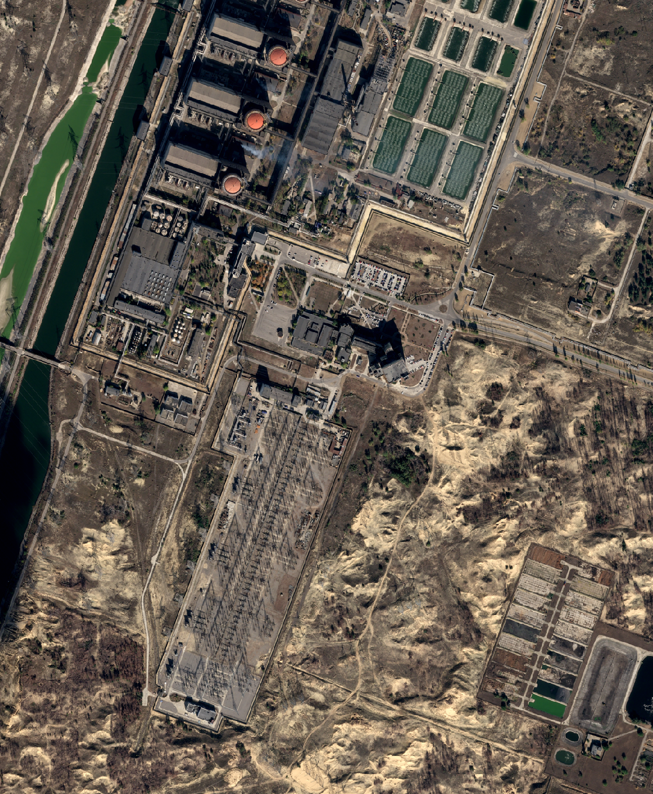
750kV transmission line at the switchyard of ZNPP Source: 15 October 2025 @Airbus

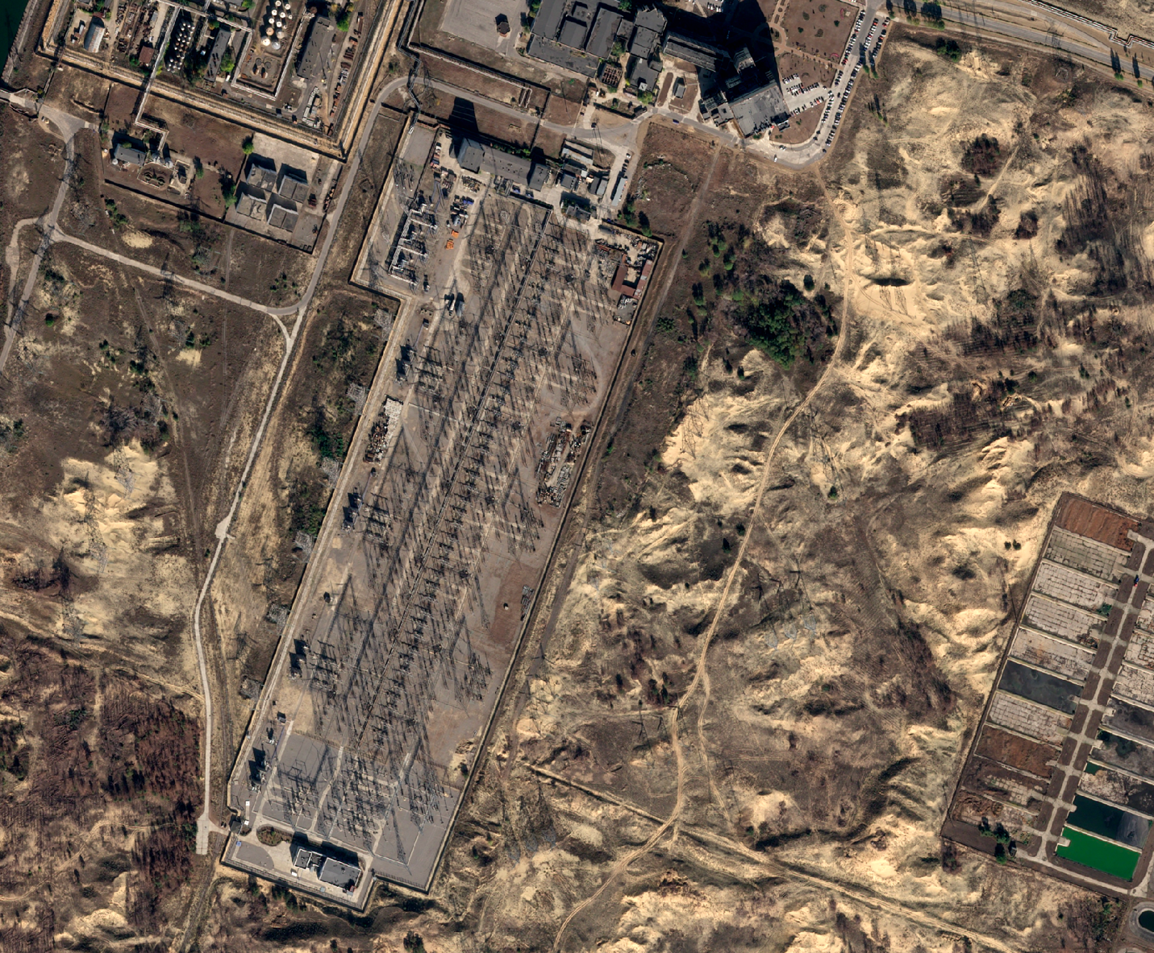
750kV transmission line at the switchyard of ZNPP Source: 15 October 2025 @Airbus

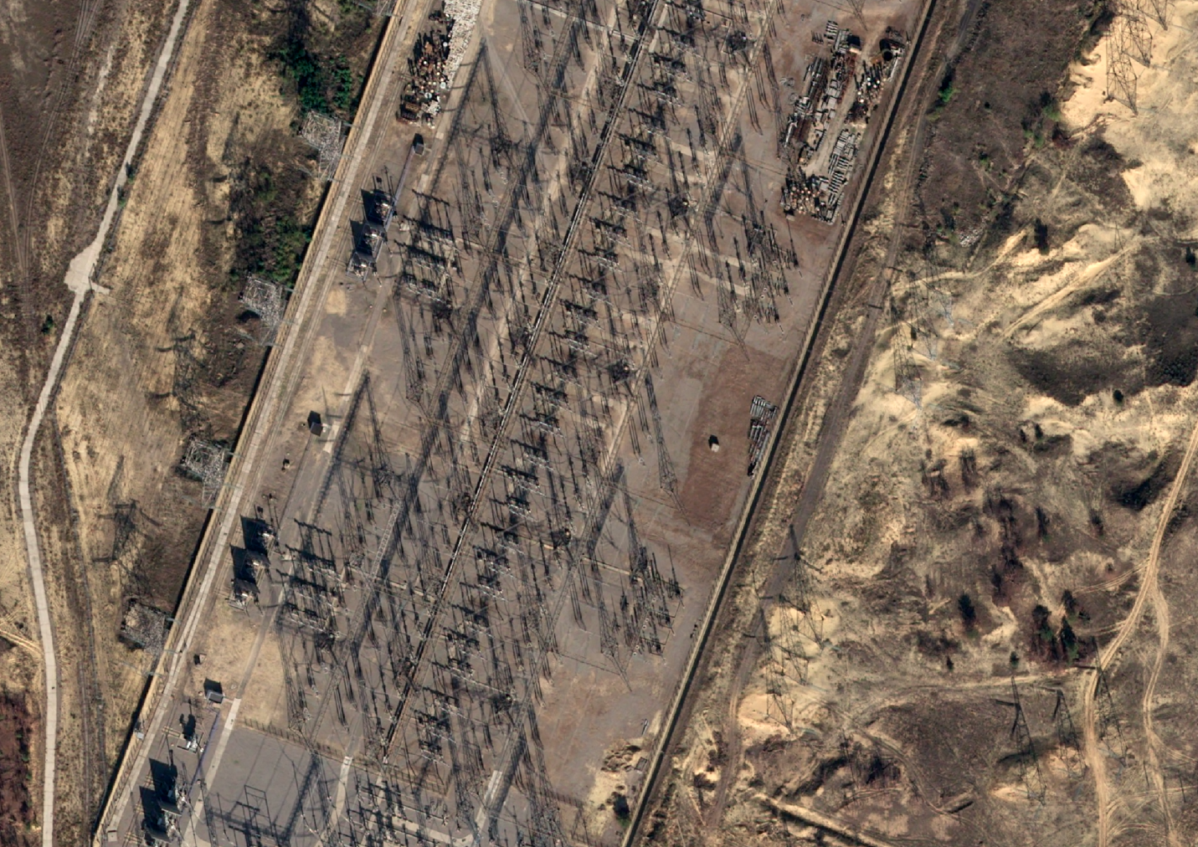
750kV transmission line at the switchyard of ZNPP Source: 15 October 2025 @Airbus

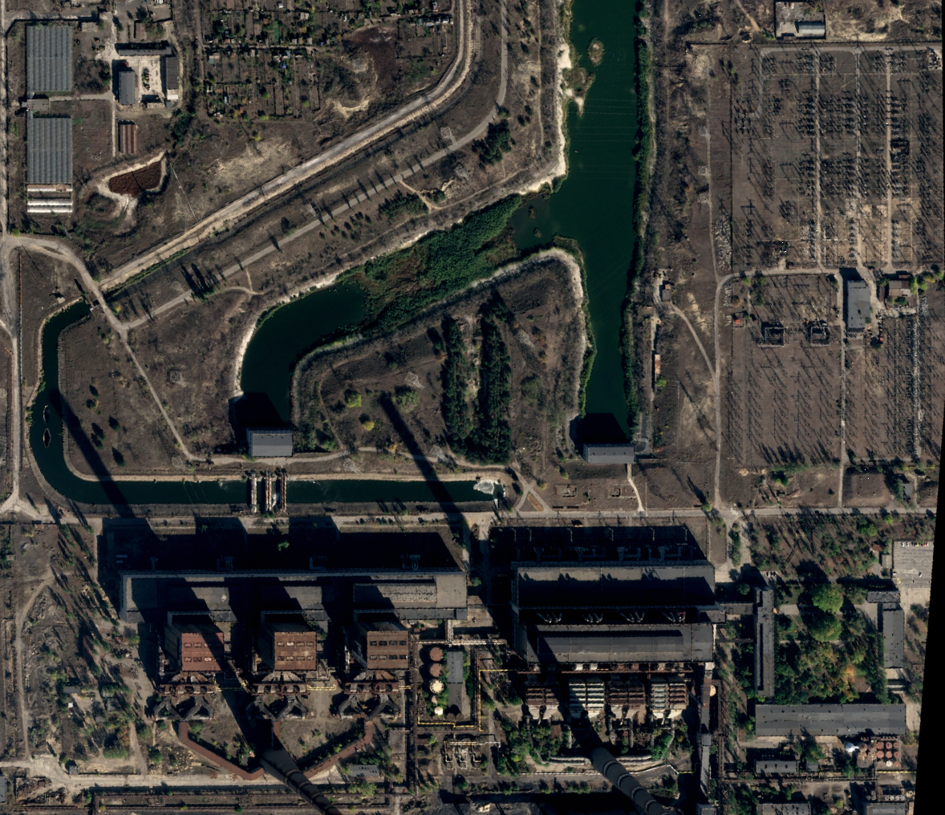
Zaporizhzhia Thermal Power Plant (ZTTP) and switchyard 15 October 2025 @Airbus

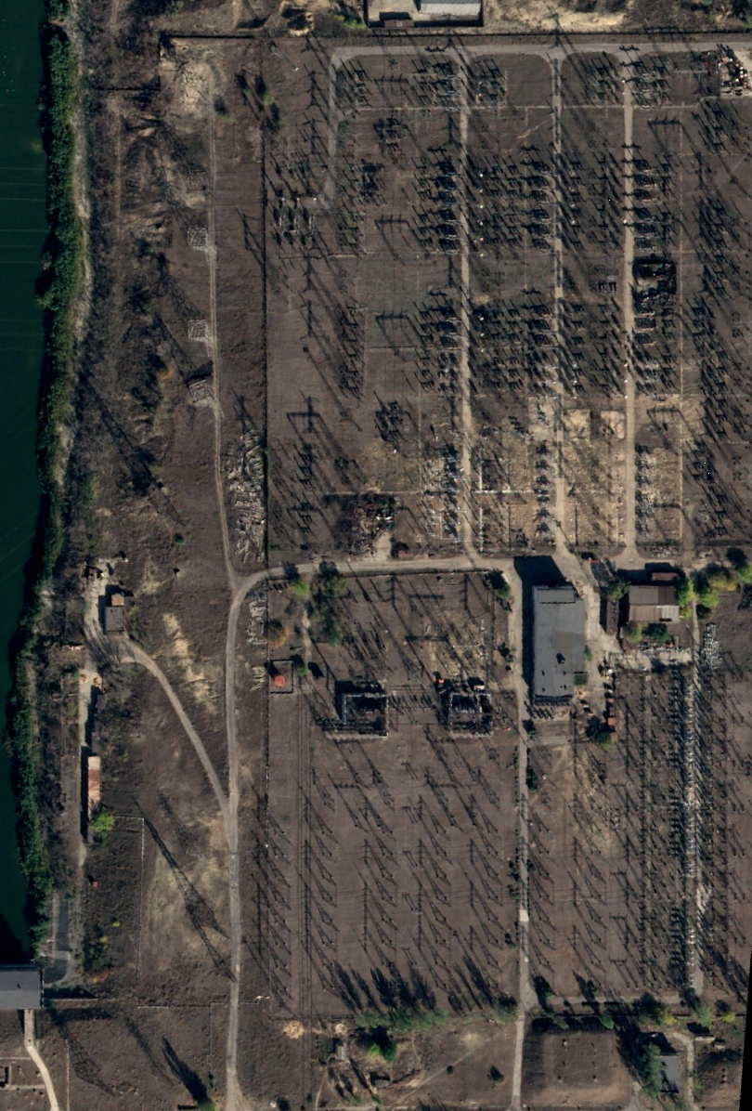
Zaporizhzhia Thermal Power Plant (ZTTP) and switchyard 15 October 2025 @Airbus

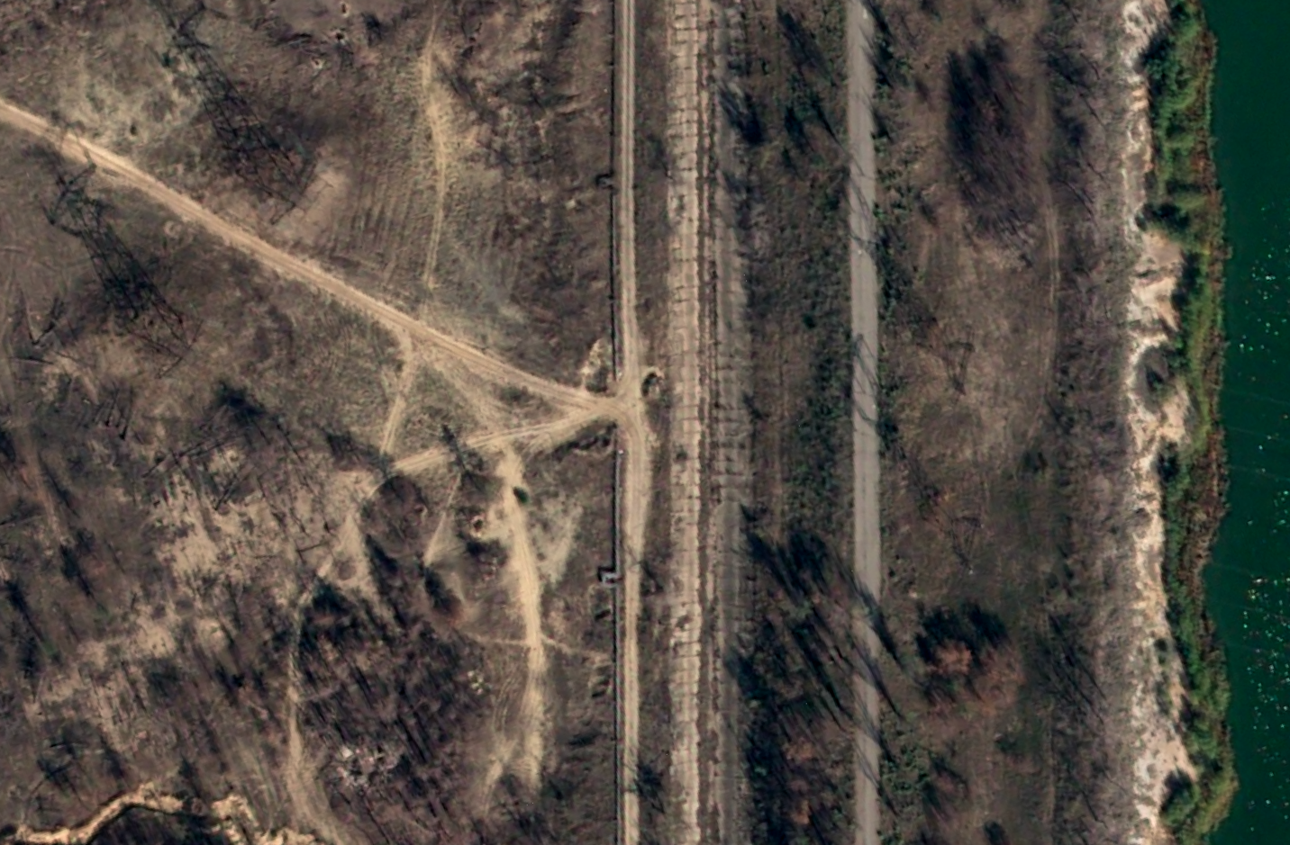
Location of Russian damaged 330kV Ferosvplavna-1 line 15 October 2025 @Airbus

Shaun Burnie, senior nuclear specialist, Greenpeace Ukraine and Jan Vande Putte, nuclear energy specialist, Greenpeace Ukraine.
Greenpeace Ukraine, Risk of unprecedented nuclear disaster if Russia’s attacks on Ukraine’s electricity system continue, 2 October 2024, see https://greenpeace.at/uploads/2024/10/copy-of-greenpeace-analysis-on-risk-of-unprecedented-nuclear-disaster-in-ukraine.pdf; and Russians again targeting critical electricity system for nuclear plants in Ukraine, 1 November 2025, see https://www.greenpeace.org/ukraine/en/news-en/4565/russians-again-targeting-critical-electricity-system-for-nuclear-plants-in-ukraine/
IAEA Director General Statement on Situation in Ukraine Update 277, 20 February 2025, see https://www.iaea.org/newscenter/pressreleases/update-277-iaea-director-general-statement-on-situation-in-ukraine
IAEA, Update 290 – IAEA Director General Statement on Situation in Ukraine, 8 May 2025, see https://www.iaea.org/newscenter/pressreleases/update-290-iaea-director-general-statement-on-situation-in-ukraine
znpp.ru - External power supply has been cut off at the Zaporizhzhia Nuclear Power Plant, 4 July 2025, see https://znpp.ru/novosti/detail.php?ELEMENT_ID=10367
SNRIU, Radiation background in the observation zone of Zaporizhzhia NPP unchanged (as of 21:00, 09/23/2025), 23 September 2025, see https://snriu.gov.ua/news/radiatsiinyi-fon-u-zoni-sposterezhennia-zaporizkoi-aes-bez- zmin-stanom-na-2100-23092025
The damage was first reported on 23 October 2025, however, as the 330kV Ferosplavna-1 line had already been damaged by Russian forces on 7 May it is not confirmed when the Russian damage was made at this other location north of the Zaporizhzhia Thermal Power Plant. It is possible that the deliberate sabotage was conducted in the same timeframe as that conducted on the 750kV Dniprovska line on 23 September 2025.
IAEA, Update 328 – IAEA Director General Statement on Situation in Ukraine 17 November 2025, see https://www.iaea.org/newscenter/pressreleases/update-328-iaea-director-general-statement-on-situation-in-ukraine
znpp.ru, Stable power supply to the Zaporizhzhia Nuclear Power Plant has been restored., 6 December 2025, see https://znpp.ru/novosti/detail.php?ELEMENT_ID=10752
znpp.ru, The Zaporizhzhia Nuclear Power Plant performed a routine shutdown from the external grid, 15 December 2025, see https://znpp.ru/novosti/detail.php?ELEMENT_ID=10758
IAEA, Update 333 – IAEA Director General Statement on Situation in Ukraine 19 December 2025, see https://www.iaea.org/newscenter/pressreleases/update-333-iaea-director-general-statement-on-situation-in-ukraine#:~:text=Ukraine's%20Zaporizhzhya%20Nuclear%20Power%20Plant,electrical%20grid%20on%2013%20December
znpp.ru, The Zaporizhzhia NPP is supplied with power from one external line, 17 December 2025, see https://znpp.ru/novosti/detail.php?ELEMENT_ID=10762
IAEA, Update 337 – IAEA Director General Statement on Situation in Ukraine 16 January 2026, see https://www.iaea.org/newscenter/pressreleases/update-337-iaea-director-general- statement-on-situation-in-ukraine
znpp.ru, As a result of the attack by the Ukrainian Armed Forces on the industrial zone of Enerhodar, the city's life support infrastructure facilities and the Zaporizhzhya NPP were damaged, 10 February 2026, see https://znpp.ru/novosti/detail.php?ELEMENT_ID=10819
IAEA, Update 341 – IAEA Director General Statement on Situation in Ukraine, 19 February 2026, see https://www.iaea.org/newscenter/pressreleases/update-341-iaea-director-general-statement-on-situation-in-ukraine

